# THE CHARTS WHICH WERE USED IS MADE OF HTML,CSS,JS ETC CODE WHICH IS ALSO ATTACHED FOR REFERENCE.( BY MADHUMITHA.B)

# IN TASK 1 : No charts , visualization is used .

# IN TASK 2: In The Equifax Breach Report (2017) we used 4 charts

## Equifax timeline chart 2. Impact of Breach

## 

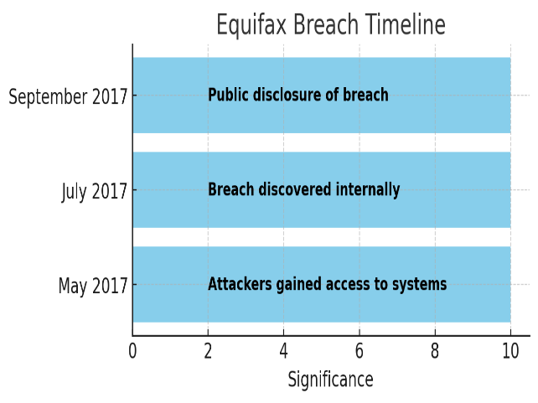 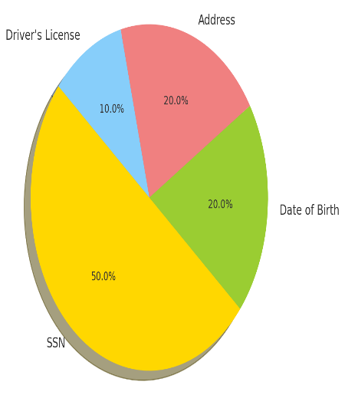

# 3.Equifax Response Timeline 4.Financial Impact

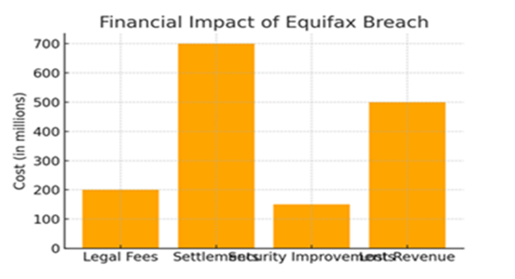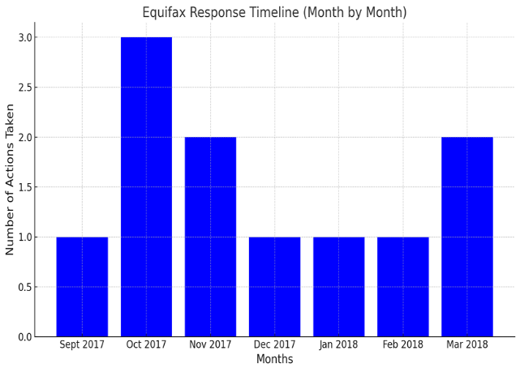

# 

# IN TASK 3:Google Data policy Analysis report I have made vizualisation chart using codes and runned in vs code (Totally 6 Charts ).

# 1.Google privacy policy clarity Analysis chart

<!DOCTYPE html>

<html>

<head>

<script type="text/javascript" src="https://www.gstatic.com/charts/loader.js"></script>

<script type="text/javascript">

google.charts.load('current', {'packages':['corechart']});

google.charts.setOnLoadCallback(drawChart);

function drawChart() {

var data = google.visualization.arrayToDataTable([

['Criteria', 'Rating (1-10)'],

['Transparency', 6.5],

['Simplicity for General Users', 5.5],

['Legal Terminology', 4.5],

['Visual Aids and Summaries', 7.5],

['Notification of Policy Changes', 8.0]

]);

var options = {

title: 'Policy Clarity Analysis'

};

var chart = new google.visualization.PieChart(document.getElementById('piechart'));

chart.draw(data, options);

}

</script>

</head>

<body>

<h1>Google Privacy Policy Clarity Analysis</h1>

<div id="piechart" style="width: 900px; height: 500px;"></div>

</body>

</html>

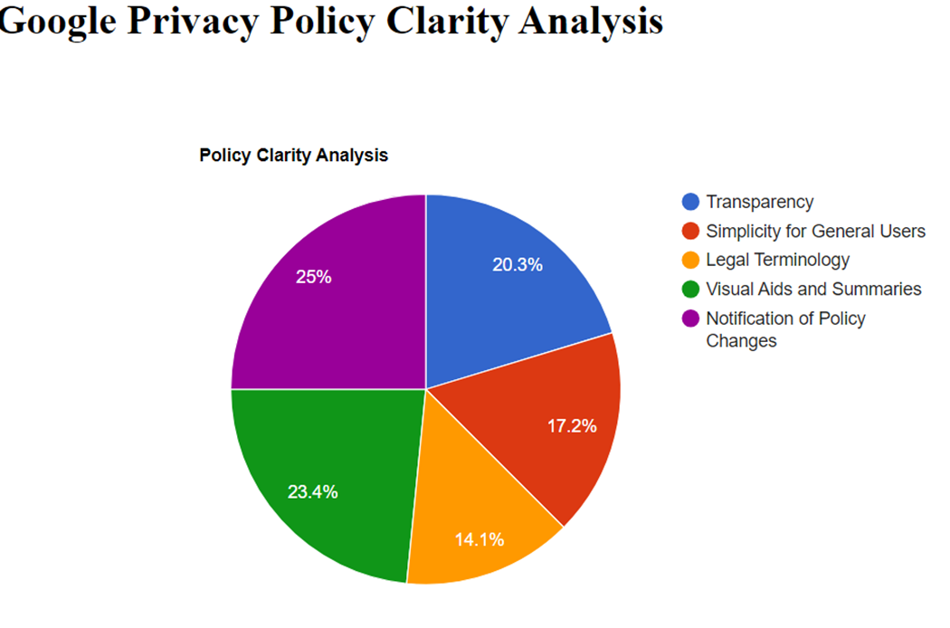

# 2.Data collection



width: 60%;

margin: 5px 0; }

</style>

</head>

<body>

<h1>

Bar Chart: Data Collection Categories</h1>

<div class="chart-container"> <div class="label">

<span>Personal Info</span> <span>4.5</span> </div>

<div class="bar" style="width: 90%;">&nbsp;</div>

<div class="label"> <span>Browsing Data</span>

<span>5.0</span> </div> <div class="bar" style="width: 100%;">&nbsp;</div>

<div class="label"> <span>Device Info</span>

<span>4.0</span> </div> <div class="bar" style="width: 80%;">&nbsp;</div>

<div class="label"> <span>Location Data</span> <span>4.5</span> </div>

<div class="bar" style="width: 90%;">&nbsp;</div>

<div class="label"> <span>Activity Data</span>

<span>5.0</span> </div>

<div class="bar" style="width: 100%;">&nbsp;</div> </div>

</body>

</html>

<!DOCTYPE html>

<html lang="en">

<head>

<meta charset="UTF-8">

<meta name="viewport" content="width=device-width, initial-scale=1.0">

<title>Bar Chart: Data Collection Categories</title>

<style>

body {

font-family: Arial, sans-serif;

margin: 20px;

}

h1 {

text-align: center;

}

.chart-container {

width: 80%;

margin: auto;

display: flex;

flex-direction: column;

align-items: center;

}

.bar {

width: 60%;

background-color: #4CAF50;

margin: 10px 0;

color: white;

text-align: right;

padding-right: 10px;

box-shadow: 0 2px 5px rgba(0, 0, 0, 0.3);

transition: width 0.3s ease;

}

.bar:hover {

opacity: 0.8;

}

.label {

display: flex;

justify-content: space-between;

width: 60%;

margin: 5px 0;

}

</style>

</head>

<body>

<h1>Bar Chart: Data Collection Categories</h1>

<div class="chart-container">

<div class="label">

<span>Personal Info</span>

<span>4.5</span>

</div>

<div class="bar" style="width: 90%;">&nbsp;</div>

<div class="label">

<span>Browsing Data</span>

<span>5.0</span>

</div>

<div class="bar" style="width: 100%;">&nbsp;</div>

<div class="label">

<span>Device Info</span>

<span>4.0</span>

</div>

<div class="bar" style="width: 80%;">&nbsp;</div>

<div class="label">

<span>Location Data</span>

<span>4.5</span>

</div>

<div class="bar" style="width: 90%;">&nbsp;</div>

<div class="label">

<span>Activity Data</span>

<span>5.0</span>

</div>

<div class="bar" style="width: 100%;">&nbsp;</div>

</div>

</body>

</html>

# 3.User Rights:



<svg width="500" height="400">

<!-- Axes -->

<line x1="50" y1="350" x2="450" y2="350" stroke="#ccc" stroke-width="2"/>

<line x1="50" y1="350" x2="50" y2="50" stroke="#ccc" stroke-width="2"/>

<!-- X-axis labels -->

<text x="100" y="370" class="label">Data Access</text>

<text x="200" y="370" class="label">Data Deletion</text>

<text x="300" y="370" class="label">Data Correction</text>

<text x="400" y="370" class="label">Data Portability</text>

<text x="450" y="370" class="label">Opt-out of Ads</text>

<!-- Y-axis labels -->

<text x="20" y="350" class="label">5</text>

<text x="20" y="280" class="label">4</text>

<text x="20" y="210" class="label">3</text>

<text x="20" y="140" class="label">2</text>

<text x="20" y="70" class="label">1</text>

<!-- Scatter points -->

<circle cx="100" cy="150" r="5" class="dot" />

<text x="100" y="145" class="label">4.0</text> <!-- Data Access -->

</svg>

</body>

</html>

<!DOCTYPE html>

<html lang="en">

<head>

<meta charset="UTF-8">

<meta name="viewport" content="width=device-width, initial-scale=1.0">

<title>Scatter Plot: Usability of User Rights</title>

<style>

body {

font-family: Arial, sans-serif;

margin: 20px;

text-align: center;

}

h1 {

margin-bottom: 20px;

}

svg {

border: 1px solid #ddd;

margin: auto;

display: block;

}

.dot {

fill: #4CAF50;

stroke: white;

stroke-width: 1.5;

}

.label {

font-size: 12px;

text-anchor: middle;

fill: #333;

}

</style>

</head>

<body>

<h1>Scatter Plot: Usability of User Rights</h1>

<svg width="500" height="400">

<!-- Axes -->

<!-- X-axis labels -->

<text x="100" y="370" class="label">Data Access</text>

<text x="200" y="370" class="label">Data Deletion</text>

<text x="300" y="370" class="label">Data Correction</text>

<text x="400" y="370" class="label">Data Portability</text>

<text x="450" y="370" class="label">Opt-out of Ads</text>

<!-- Y-axis labels -->

<text x="20" y="350" class="label">5</text>

<text x="20" y="280" class="label">4</text>

<text x="20" y="210" class="label">3</text>

<text x="20" y="140" class="label">2</text>

<text x="20" y="70" class="label">1</text>

<!-- Scatter points -->

<circle cx="100" cy="150" r="5" class="dot" />

<text x="100" y="145" class="label">4.0</text> <!-- Data Access -->

<circle cx="200" cy="185" r="5" class="dot" />

<text x="200" y="180" class="label">3.5</text> <!-- Data Deletion -->

<circle cx="300" cy="215" r="5" class="dot" />

<text x="300" y="210" class="label">3.0</text> <!-- Data Correction -->

<circle cx="400" cy="125" r="5" class="dot" />

<text x="400" y="120" class="label">4.5</text> <!-- Data Portability -->

<circle cx="100" cy="150" r="5" class="dot" />

<text x="100" y="145" class="label">4.0</text> <!-- Opt-out of Ads -->

</svg>

</body>

</html>

# 4.Security Measure Effectiveness



fill: #333;

}

</style>

</head>

<body>

<h1>Box Plot: Security Measures</h1>

<svg width="600" height="400">

<!-- Axes -->

<line x1="50" y1="350" x2="550" y2="350" stroke="#333" stroke-width="2"/>

<line x1="50" y1="350" x2="50" y2="50" stroke="#333" stroke-width="2"/>

<text x="550" y="370" class="label">Two-Factor Authentication</text>

<circle cx="550" cy="200" r="3" class="dot"/>

</svg>

</body>

</html>

<!DOCTYPE html>

<html lang="en">

<head>

<meta charset="UTF-8">

<meta name="viewport" content="width=device-width, initial-scale=1.0">

<title>Box Plot: Security Measures</title>

<style>

body {

font-family: Arial, sans-serif;

margin: 20px;

text-align: center;

}

h1 {

margin-bottom: 20px;

}

svg {

border: 1px solid #ddd;

margin: auto;

display: block;

}

.box {

fill: #4CAF50;

stroke: white;

stroke-width: 1.5;

}

.line {

stroke: #333;

stroke-width: 2;

}

.dot {

fill: #FF5722;

stroke: white;

stroke-width: 1.5;

}

.label {

font-size: 12px;

text-anchor: middle;

fill: #333;

}

</style>

</head>

<body>

<h1>Box Plot: Security Measures</h1>

<svg width="600" height="400">

<!-- Axes -->

<line x1="50" y1="350" x2="550" y2="350" stroke="#333" stroke-width="2"/>

<line x1="50" y1="350" x2="50" y2="50" stroke="#333" stroke-width="2"/>

<!-- X-axis labels -->

<text x="150" y="370" class="label">Encryption (in transit)</text>

<text x="250" y="370" class="label">Encryption (at rest)</text>

<text x="350" y="370" class="label">Incident Response</text>

<text x="450" y="370" class="label">Internal Access Control</text>

<text x="550" y="370" class="label">Two-Factor Authentication</text>

<!-- Box Plot Representation -->

<!-- Encryption (in transit) -->

<rect x="120" y="150" width="60" height="100" class="box"/>

<line x1="120" y1="200" x2="180" y2="200" class="line"/>

<circle cx="150" cy="200" r="3" class="dot"/>

<!-- Encryption (at rest) -->

<rect x="220" y="150" width="60" height="100" class="box"/>

<line x1="220" y1="200" x2="280" y2="200" class="line"/>

<circle cx="250" cy="200" r="3" class="dot"/>

<!-- Incident Response -->

<rect x="320" y="175" width="60" height="75" class="box"/>

<line x1="320" y1="200" x2="380" y2="200" class="line"/>

<circle cx="350" cy="200" r="3" class="dot"/>

<!-- Internal Access Control -->

<rect x="420" y="200" width="60" height="50" class="box"/>

<line x1="420" y1="225" x2="480" y2="225" class="line"/>

<circle cx="450" cy="225" r="3" class="dot"/>

<!-- Two-Factor Authentication -->

<rect x="520" y="150" width="60" height="100" class="box"/>

<line x1="520" y1="200" x2="580" y2="200" class="line"/>

<circle cx="550" cy="200" r="3" class="dot"/>

</svg>

</body>

</html>

# 5.Compilance with GDPR vs CCPA

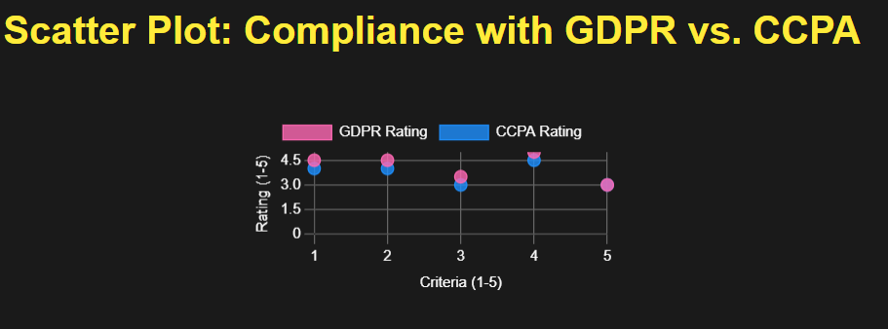

<h1 style="color: #FFFFFF;">Scatter Plot: Compliance with GDPR vs. CCPA</h1> <!-- White title for visibility -->

<div id="chart_div"></div>

</body>

</html>

<!DOCTYPE html>

<html lang="en">

<head>

<meta charset="UTF-8">

<meta name="viewport" content="width=device-width, initial-scale=1.0">

<title>Scatter Plot: Compliance with GDPR vs. CCPA</title>

<script type="text/javascript" src="https://www.gstatic.com/charts/loader.js"></script>

<script type="text/javascript">

google.charts.load('current', {'packages':['corechart']});

google.charts.setOnLoadCallback(drawChart);

function drawChart() {

var data = google.visualization.arrayToDataTable([

['Criteria', 'GDPR', 'CCPA'],

['Data Collection Transparency', 4.5, 4.0],

['User Rights', 4.5, 4.0],

['Third-Party Data Sharing', 3.5, 3.0],

['Cookie Consent', 5.0, 4.5],

['Data Retention Policies', 3.0, 3.0]

]);

var options = {

title: 'Compliance with GDPR vs. CCPA',

backgroundColor: '#A67C00', // Dark mustard background

hAxis: {

title: 'GDPR Ratings (1-5)',

minValue: 0,

maxValue: 5,

ticks: [0, 1, 2, 3, 4, 5],

textStyle: { color: '#FFFFFF' } // White text for the x-axis

},

vAxis: {

title: 'CCPA Ratings (1-5)',

minValue: 0,

maxValue: 5,

ticks: [0, 1, 2, 3, 4, 5],

textStyle: { color: '#FFFFFF' } // White text for the y-axis

},

legend: { position: 'top', textStyle: { color: '#FFFFFF' } }, // White legend text

series: {

0: { color: '#FF69B4' }, // Pink for GDPR

1: { color: '#00BFFF' } // Deep Sky Blue for CCPA

},

pointSize: 10,

height: 400,

width: 600

};

var chart = new google.visualization.ScatterChart(document.getElementById('chart_div'));

chart.draw(data, options);

}

</script>

</head>

<body>

<h1 style="color: #FFFFFF;">Scatter Plot: Compliance with GDPR vs. CCPA</h1> <!-- White title for visibility -->

<div id="chart_div"></div>

</body>

</html>

# 6.Recommendation vs Current practises

],

datasets: [{

label: 'Current Practice Rating',

data: [3.0, 3.5, 3.0, 3.0, 4.0],

backgroundColor: 'rgba(255, 105, 180, 0.2)', // Pinkish for transparency

borderColor: 'rgba(255, 105, 180, 1)', // Pinkish border

pointBackgroundColor: 'rgba(255, 105, 180, 1)',

pointBorderColor: '#fff',

pointHoverBackgroundColor: '#fff',

pointHoverBorderColor: 'rgba(255, 105, 180, 1)'

}

}

},

plugins: {

legend: {

labels: {

color: '#FFFFFF' // White text for legend

}

});

</script>

</body>

</html>

<!DOCTYPE html>

<html lang="en">

<head>

<meta charset="UTF-8">

<meta name="viewport" content="width=device-width, initial-scale=1.0">

<title>Radar Chart: Recommendations vs Current Practices</title>

<script src="https://cdn.jsdelivr.net/npm/chart.js"></script>

<style>

body {

background-color: #1A1A1A; /* Dark background */

color: #FFFFFF; /* White text */

font-family: Arial, sans-serif;

text-align: center;

}

h1 {

color: #FFEB3B; /* Light mustard yellow for header */

}

#radarChart {

max-width: 600px;

margin: 50px auto;

}

</style>

</head>

<body>

<h1>Radar Chart: Recommendations vs Current Practices</h1>

<canvas id="radarChart"></canvas>

<script>

const ctx = document.getElementById('radarChart').getContext('2d');

const radarChart = new Chart(ctx, {

type: 'radar',

data: {

labels: [

'Simplifying User Rights',

'Data Minimization',

'Third-Party Sharing Transparency',

'Internal Access Control',

'Clarity of Policy Language'

],

datasets: [{

label: 'Current Practice Rating',

data: [3.0, 3.5, 3.0, 3.0, 4.0],

backgroundColor: 'rgba(255, 105, 180, 0.2)', // Pinkish for transparency

borderColor: 'rgba(255, 105, 180, 1)', // Pinkish border

pointBackgroundColor: 'rgba(255, 105, 180, 1)',

pointBorderColor: '#fff',

pointHoverBackgroundColor: '#fff',

pointHoverBorderColor: 'rgba(255, 105, 180, 1)'

}, {

label: 'Suggested Improvement',

data: [5.0, 4.5, 4.5, 4.5, 5.0],

backgroundColor: 'rgba(30, 144, 255, 0.2)', // Light blue for transparency

borderColor: 'rgba(30, 144, 255, 1)', // Light blue border

pointBackgroundColor: 'rgba(30, 144, 255, 1)',

pointBorderColor: '#fff',

pointHoverBackgroundColor: '#fff',

pointHoverBorderColor: 'rgba(30, 144, 255, 1)'

}]

},

options: {

responsive: true,

scales: {

r: {

angleLines: {

color: '#FFFFFF' // White grid lines

},

grid: {

color: '#666666' // Dark gray grid lines

},

ticks: {

color: '#FFFFFF', // White tick labels

backdropColor: '#1A1A1A', // Dark background behind tick labels

min: 0,

max: 5,

stepSize: 1

},

pointLabels: {

color: '#FFFFFF', // White labels around the chart

}

}

},

plugins: {

legend: {

labels: {

color: '#FFFFFF' // White text for legend

}

}

}

}

});

</script>

</body>

</html>

